**Lab Exercises**

Class: 软件1803 Name: 朱玥潼 StuID:___201816040326___

Date: 2019.12.25 Score:

**Lab Exercise — Overloading printArray**

**I Lab Objectives**

In this lab, you will practice:

1. Overloading a function template for printing an array.
2. Using function templates to create function-template specializations.

**II Description of the Problem**

Overload function template printArray so that it takes two additional integer arguments, namely int lowSubscript and int highSubscript. A call to this function will print only the designated portion of the array. Validate lowSubscript and highSubscript; if either is out of range or if highSubscript is less than or equal to lowSubscript, the overloaded printArray function should return 0; otherwise, printArray should return the number of elements printed. Then modify main to demonstrate both versions of printArray on arrays a, b and c. Be sure to test all capabilities of both versions of printArray.

//Original program

// Using function-template specializations.

#include <iostream>

using namespace std;

// function template printArray definition

template< typename T >

void printArray( const T * const array, int count )

{

for ( int i = 0; i < count; ++i )

cout << array[ i ] << " ";

cout << endl;

} // end function template printArray

int main()

{

const int aCount = 5; // size of array a

const int bCount = 7; // size of array b

const int cCount = 6; // size of array c

int a[ aCount ] = { 1, 2, 3, 4, 5 };

double b[ bCount ] = { 1.1, 2.2, 3.3, 4.4, 5.5, 6.6, 7.7 };

char c[ cCount ] = "HELLO"; // 6th position for null

cout << "Array a contains:" << endl;

// call integer function-template specialization

printArray( a, aCount );

cout << "Array b contains:" << endl;

// call double function-template specialization

printArray( b, bCount );

cout << "Array c contains:" << endl;

// call character function-template specialization

printArray( c, cCount );

} // end main

**III Sample Output**

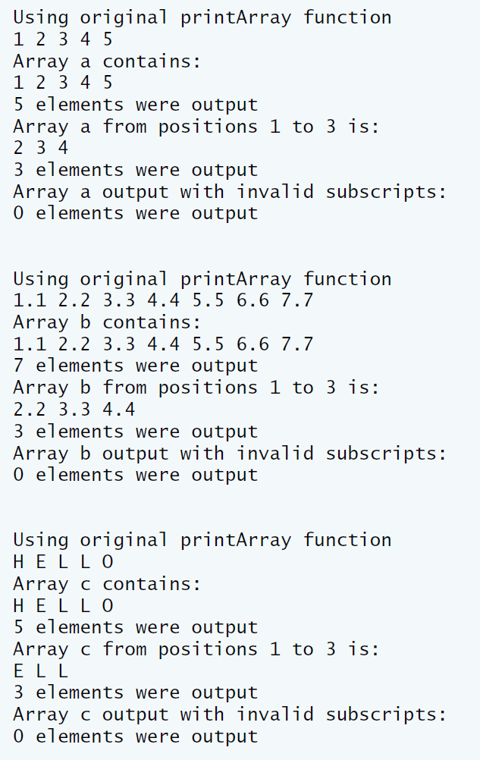

**IV Problem-Solving Tips**

1. To overload the printArray function template, declare another function template, also named printArray, that takes two additional int parameters, lowSubscript and highSubscript.
2. When iterating over the range from lowSubscript to highSubscript, make sure to include both values within the range, to avoid an off-by-one error.

**V Your Solution**

// Lab 1: TemplateOverload.cpp

// Using template functions

#include <iostream>

using namespace std;

// function template printArray definition

// original function

template< typename T >

void printArray( const T *array, int count1 )

{

// display array

for ( int i = 0; i < count1; i++ )

cout << array[ i ] << " ";

cout << endl;

} // end function printArray

template< typename T >

int printArray( const T *array, int count1, int lowSubscript, int highSubscript )

{

// check if subscript is negative or out of range

if (!( highSubscript > lowSubscript && ( highSubscript < count1 || highSubscript == count1 ) && ( lowSubscript > 0 || lowSubscript == 0) ) )

return 0;

int count2 = 0;

// display array

for ( int i = lowSubscript ; i <= highSubscript ;i++ )

{

++count2;

cout << array[ i ] << ' ';

} // end for

cout << '\n';

return count2; // number or elements output

} // end overloaded function printArray

int main()

{

const int ACOUNT = 5; // size of array a

const int BCOUNT = 7; // size of array b

const int CCOUNT = 6; // size of array c

int a[ ACOUNT ] = { 1, 2, 3, 4, 5 };

double b[ BCOUNT ] = { 1.1, 2.2, 3.3, 4.4, 5.5, 6.6, 7.7 };

char c[ CCOUNT ] = "HELLO"; // 6th position for null

int elements;

cout << "\nUsing original printArray function\n";

printArray( a, ACOUNT );

cout << "Array a contains:\n";

elements = printArray( a , ACOUNT , 0, ACOUNT - 1);

cout << elements << " elements were output\n";

cout << "Array a from positions 1 to 3 is:\n";

elements = printArray(a,ACOUNT, 1, 3);

cout << elements << " elements were output\n";

cout << "Array a output with invalid subscripts:\n";

elements = (a,ACOUNT, -1, 10);

cout << elements << " elements were output\n\n";

cout << "\nUsing original printArray function\n";

printArray( b, BCOUNT );

cout << "Array b contains:\n";

elements = printArray( b , BCOUNT , 0 , BCOUNT - 1);

cout << "Array b from positions 1 to 3 is:\n";

elements = printArray( b , BCOUNT , 1 , 3);

cout << elements << " elements were output\n";

cout << "Array b output with invalid subscripts:\n";

elements = printArray( b , BCOUNT , -1 , 10);

cout << elements << " elements were output\n\n";

cout << "\nUsing original printArray function\n";

printArray( c, CCOUNT );

cout << "Array c contains:\n";

elements = printArray( c , CCOUNT , 0, CCOUNT - 2 );

cout << elements << " elements were output\n";

cout << "Array c from positions 1 to 3 is:\n";

elements = printArray( c , CCOUNT , 1 , 3 );

cout << elements << " elements were output\n";

cout << "Array c output with invalid subscripts:\n";

elements = printArray( c , CCOUNT , -1 , 10 );

cout << elements << " elements were output" << endl;

} // end main

